**KL UNIVERSITY**



**DEPARTMENT OF COMPUTER SCIENCE ENGINEERING**

**COURSE CODE -17CS2210**

**DATABASE MANAGEMENT SYSTEMS**

**II B.TECH – II SEMESTER**

**ACADEMIC YEAR 2018-2019**

**PROJECT BASED LAB**

**ON**

**KLU ALUMNI DATABASE MANAGEMENT SYSTEM**

**SUBMITTED BY**

**SECTION – S17**

**BATCH NO: 7**

|  |  |
| --- | --- |
| Student ID | Student Name |
| 170030608 | K.Nagalakshmi |
| 170030617 | K.Meghana |
| 170030656 | K.Tarun Sai |
| 170030667 | K.Hari Venkata Swaraj |

**K L University**

**DEPARTMENT OF COMPUTER SCIENCE ENGINEERING**



**CERTIFICATE**

This is to certify that the course based project entitled **“KLU ALUMNI DATA BASE MANAGEMENT SYSTEM”** is a bonafide work done by K.Nagalakshmi(170030608),K.Meghana(170030617),K.TarunSai(170030656), K.Hari Venkata Swaraj(170030667)in partial fulfilment of the requirement for the award of degree in **BACHELOR OF TECHNOLOGY** in **Computer Science Engineering** during the academic year **2018-2019.**

**FACULTY IN CHARGE HEAD OF THE DEPARTMENT**

**G.Krishna Mohan Dr Hari Kiran Vege**

**DEPARTMENT OF COMPUTER SCIENCE ENGINEERING**



**DECLARATION**

We hereby declare that this project based lab report entitled **“KLU ALUMNI DATA BASE MANAGEMENT”** has been prepared by us in partial fulfil ment of the requirement for the award of degree “**BACHELOR OF TECHNOLOGY in COMPUTER SCIENCE ENGINEERING**” during the academic year 2018-2019.

We also declare that this project based lab report is of our own effort and it has not been submitted to any other university for the award of any degree.

**Date: 23-03-2019**

**Place: Vaddeswaram**

|  |  |
| --- | --- |
| Name | Student ID |
| K.Nagalakshmi | 170030608 |
| K.Meghana | 170030617 |
| K.Tarun Sai | 170030656 |
| K. Swaraj | 170030667 |

**ACKNOWLEDGEMENTS**

Our sincere thanks to **G.Krishna Mohan** in the Lab for his outstanding support throughout the project for the successful completion of the work.

My sincere thanks to **Dr D.Haritha** Course coordinator of Data base system for helping us in the completion of our project based laboratory.

We express our gratitude to **Dr Hari Kiran Vege** Head of the Department for Computer Science and Engineering for providing us with adequate facilities, ways and means by which we are able to complete this term paper work.

We would like to place on record the deep sense of gratitude to the honourable Vice Chancellor, K L University for providing the necessary facilities to carry the concluded term paper work.

Last but not the least, we thank all Teaching and Non-Teaching Staff of our department and especially my classmates and my friends for their support in the completion of our project work.

Finally, it is pleased to acknowledge the indebtedness to all those who devoted themselves directly or indirectly to make this project report success.

**PROJECT ASSOCIATES**

|  |  |
| --- | --- |
| Name | Student ID |
| K.Nagalakshmi | 170030608 |
| K.Meghana | 170030617 |
| K.Tarun Sai | 170030656 |
| K. Swaraj | 170030667 |

**TABLE OF CONTENTS**

Abstract 6

Introduction 7

PROJECT DESCRIPTION 8

List of Entities & Attributes 10

ER Diagram (Conceptual Model) 14

Schema Diagram 15

Normalization & Final List of Relations 16

Create & Insert SQL Queries 18

SQL Queries related to Report Generation 21

Conclusion 27

**ABSTRACT**

Alumni are an association of graduates or broadly the former students of a university. The title of the project is KL University Alumni database . The information system for communication with graduates represents one of many ways how university can keep in touch with its graduates. Except for communication between university and its graduates, the information system should allow communication between graduates themselves and their personal presentation in public. An alumni database is very essential to carry out crucial activities like institute events, fundraising and to maintain contacts with the corporate organizations in which the alumni are working. The information system for communication with graduates represents one of many ways how university can keep in touch with its graduates. An alumni database management system brings a university’s alumni on one platform, organize them batch wise, location wise and their functional area, which in turn helps the university to communicate with the alumni effectively for various purposes. It is also used to maintain the data of the alumni as well as the corporate supporters who offer funds to the university. The presented information system includes all these points and focuses on security, usability and comfortable user interface. In this we design a computerized database for KL University Alumni. The database captures all relevant information on alumni of the college and the corporate supporters of the university.

**INTRODUCTION**

Database is an organized collection of data. The data is typically organized to model aspects of reality in a way that supports processes requiring information. A DBMS makes it possible for end users to create, read, update and delete data in a database. The DBMS essentially serves as an interface between the database and end users or application programs, ensuring that data is consistently organized and remains easily accessible. The DBMS manages three important things: the data, the database engine that allows data to be accessed, locked and modified and the database schema, which defines the database’s logical structure. These three foundational elements help provide concurrency, security, data integrity and uniform administration procedures. The DBMS can offer both logical and physical data independence. That means it can protect users and applications from needing to know where data is stored or having to be concerned about changes to the physical structure of data.

The aim of this Alumni Management System project is to build a system that will be able to manage alumni data of a college and provide easy access . Contact between alumni can be used to forge business connections and to gain references or insight in a new field. It is also used to maintain the data of the alumni as well as the corporate supporters who offer funds to the university.

**PROBLEM DESCRIPTION**

The Dean of the business school wishes to create an UTD “family” consisting of its graduates and corporations that have been staunch supporters of the School of Management. Finding the existing database inadequate in terms of providing him with the information he needs to achieve his goal, he wishes to develop a new alumni database for the college. He wants the new database to capture all relevant information on alumni of the college and the corporate supporters of the college. To build a long-term relationship with alumni, he wishes to keep track of all alumni from each functional area (e.g., MIS, Acctg, Fin, Mkt, etc.) of the college, where they work (or have worked in the past), and any donations that they have made to the college. Similarly, for corporate supporters, the database must capture all relevant information on donations made by each corporation.

Upon further interviews with the Dean, he has indicated the following specific requirements:

1. A report that displays alumni information for a specified area for a particular year (e.g., 1999 MIS graduates). The report should list, for the specified area and year of graduation, each alumnus’s name, e-mail address, the degree earned (e.g., BS, MS, MBA, Ph.D., etc.), work phone number, and home phone number. Note that a similar report could be required for any area and any graduating year.

2. For a specified city, a report listing all alumni who live in that city. The report will display the name of the city, and for each alumnus in that city, their name, home address, email address, work phone, and home phone.

3. A report listing all corporate donors who have donated a total amount greater than Rs.25,000. The report will be sorted in descending order of the donated amount.

4. A report that displays all donations made to a particular G/L (General Ledger) account. The ID of the donor, as well as the date and amount of the donation must be displayed.

5. A report listing all alumni working for a particular company. This report must also display the date an individual joined the company, as well as, their job title and salary.

6. A report that displays the employment history for a particular alumnus. The report must show, for each employer that alumnus has worked for, the employer name, the most recent job title the alumnus had with that employer company (e.g., Vice-President), the date the alumnus joined the company, and the date the alumnus left the company (if applicable).

**LIST OF ENTITIES AND ATTRIBUTES**

**List of entities:**

1.Alumni

2. Company

3.Corporate Supporters

4.University

5.Fund

**List of attributes:**

1.Alumini

* Alumni id
* Alumini name
* Email
* Degree
* Phone number-residence/ personal (multivalued attribute)
* Graduating year
* Functional area
* Home address- door no,street,city,state,pincode (composite attribute)

2. Company

* Company id
* Company industry code
* Join date
* Left date
* Job title
* Salary
* Employer name
* Employee id

3. Corporate supporters

* Corporation-id
* Corporation name
* Address
* Phn number

4.University

* Branch id
* Address
* Phn no

5.Fund

* Fund id
* Donor id
* Amount
* Type of fund
* Date of donation
* Account type

**List of relationships:**

* An alumni works for the university

Name of the relation: works

Cardinality: A:U=N:1

Participation: A:U =partial: full

* An alumni works for a company

Name of the relation: works

Cardinality: A:C=N:1

Participation: A:U= partial :full

* An alumni donates fund to the university

Name of the relation: donates

Cardinality: A: F:U= N:N:1

Participation: A:F:U= partial :partial:full

* A corporation donates fund to the university

Name of the relation: donates

Cardinality: C:F:U=N:N:1

Participation: C:U= partial :partial:full

**List of Constraints:**

* An alumni’s name has both first and last names
* The address of an alumni is a composite attribute that includes the door number, street, city ,state and pin code.
* The contact number of an alumni is a multivalued attribute that may include an alumni’s residence and mobile phone numbers.
* The email of an alumni is a multivalued attribute that may include an alumni’s personal and university mail ids.
* A company’s ID number is a 7 digit number uniquely identifying a particular company and a company’s industry id is a 3 digit code.

**List of assumptions:**

* There cannot be a university in which no alumni is working
* There can be some alumni who are not working in a university
* There cannot be a company in which no alumni of the university is working
* There can be some alumni who are not working in any company
* There cannot be any university that does not receive donation from any alumni
* There can be some alumni who are not donating fund to the university
* There cannot be any university that does not receive donation from any corporation
* There cannot be any corporation that is not donating fund to the university

**ER DIAGRAM (CONCEPTUAL MODEL)**

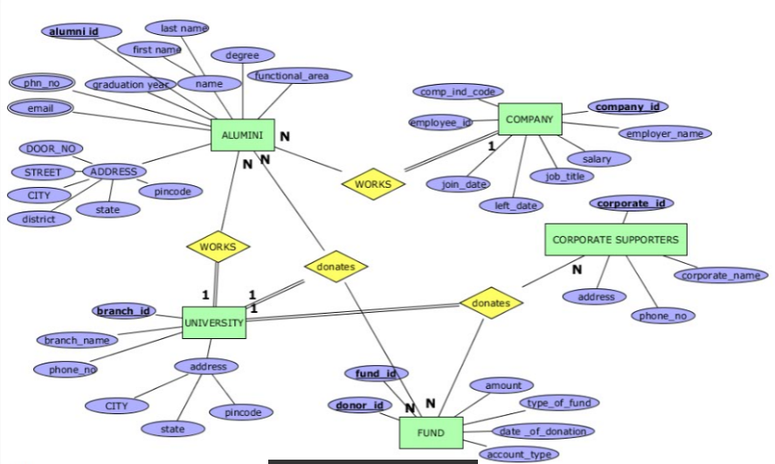

**SCHEMA DIAGRAM**

**ALUMNI**

|  |  |  |  |  |  |  |
| --- | --- | --- | --- | --- | --- | --- |
| alumni_id | first_name | last_name | degree | graduation_year | function_area | door_no |
| street | city | state | pincode | company_id(FK) | branch_id(FK) |  |

**COMPANY**

|  |  |  |  |  |  |  |  |
| --- | --- | --- | --- | --- | --- | --- | --- |
| comp_id | com_ind_code | emp_name | emp_id | join_date | left_date | job_title | salary |

**CORPORATE_SUPPORTERS**

|  |  |  |  |  |  |  |
| --- | --- | --- | --- | --- | --- | --- |
| corporate_id | corporate_name | ph_no | location | city | state | pincode |

**UNIVERSITY**

|  |  |  |  |  |  |
| --- | --- | --- | --- | --- | --- |
| branch_id | branch_name | ph_no | city | state | pincode |

**FUND**

|  |  |  |  |  |  |
| --- | --- | --- | --- | --- | --- |
| fund_id | donor_id | amount | type_of_fund | date_of_donation | account_type |

**ALUMNI_PHONE**

|  |  |  |  |
| --- | --- | --- | --- |
| ph_id | ph_type | ph_number | alumni_id(FK) |

**ALUMNI_EMAIL**

|  |  |  |  |  |
| --- | --- | --- | --- | --- |
| alumniemail_id |  | email_type | email_id | alumni_id(FK) |

**ALUMNI_DONATION**

|  |  |  |  |
| --- | --- | --- | --- |
| al_donation_id | alumni_id(FK) | fund_id(FK) | branch_id(FK) |

**CORP_DONATIONS**

|  |  |  |  |
| --- | --- | --- | --- |
| Cor_donation_id | corporate_id(FK) | fund_id(FK) | branch_id(FK) |

**NORMALIZATION AND FINAL LIST OF RELATIONS**

CORPORATE_SUPPORTERS

|  |  |
| --- | --- |
| Corporate_id | pincode |

|  |  |  |  |
| --- | --- | --- | --- |
| Pincode | location | city | state |

|  |  |  |
| --- | --- | --- |
| Corporate_id | Corporation_name | Phn_no |

COMPANY

|  |  |
| --- | --- |
| Comp_id | Emp_no |

|  |  |
| --- | --- |
| Comp_id | Comp_ind_code |

|  |  |  |  |  |  |
| --- | --- | --- | --- | --- | --- |
| Emp_no | Emp_name | Join_date | Left_date | Job_title | salary |

FUND

|  |  |
| --- | --- |
| Fund_id | Donor_id |

|  |  |  |
| --- | --- | --- |
| Fund_id | Type_of_fund | amount |

|  |  |  |  |
| --- | --- | --- | --- |
| Donor_id | amount | Date_of_donation | Account_type |

ALUMNI

|  |  |  |  |  |  |  |  |  |  |  |  |  |
| --- | --- | --- | --- | --- | --- | --- | --- | --- | --- | --- | --- | --- |
| Alumni  _id | First  _name | Last  _name | degree | Grad_  year | Fun_  area | Door_  no | street | city | state | pincode | Comp_  id | Branch  _id |

UNIVERSITY

|  |  |  |  |  |  |
| --- | --- | --- | --- | --- | --- |
| Branch_id | Branch_name | Phn_no | city | state | pincode |

ALUMNI_PHONE

|  |  |  |  |
| --- | --- | --- | --- |
| Phn_id | Phn_type | Phn_number | Alumni_id |

ALUMNI_EMAIL

|  |  |  |  |
| --- | --- | --- | --- |
| Ae_id | Email_type | Email_id | Alumni_id |

AL_DONATION

|  |  |  |  |
| --- | --- | --- | --- |
| Al_doantion_id | Alumni_id | Fund_id | Branch_id |

COR_DONATION

|  |  |  |  |
| --- | --- | --- | --- |
| Corp_donation_id | Corporate_id | Fund_id | Branch_id |

**CREATE AND INSERT SQL QUERIES**

create table if not exists ALUMNI (al_id int PRIMARY KEY NOT NULL,f_name varchar(20) NOT NULL,l_name varchar(20) NOT NULL, degree varchar(50) NOT NULL,grad_year YEAR NOT NULL,fun_area varchar(90) NOT NULL,door_no varchar(10) NOT NULL,street varchar(20) NOT NULL,city varchar(20) NOT NULL,state varchar(40) NOT NULL,pincode DECIMAL(6,0) NOT NULL,com_id int NOT NULL,branch_id int NOT NULL );

create table if not exists COMPANY(com_id int PRIMARY KEY NOT NULL,com_ind_code int NOT NULL,emp_name varchar(20) NOT NULL,emp_id int NOT NULL,join_date DATE NOT NULL ,job_title varchar(30) NOT NULL,salary int NOT NULL, left_date DATE);

create table if not exists CORPORATE_SUPPORTERS(cor_id int PRIMARY KEY NOT NULL,cor_name varchar(40) NOT NULL,phn_no bigint NOT NULL,location varchar(50) NOT NULL,city varchar(20) NOT NULL,state varchar(40) NOT NULL,pincode DECIMAL(6,0) NOT NULL);

create table if not exists UNIVERSITY (branch_id int PRIMARY KEY NOT NULL,branch_name varchar(20) NOT NULL,phn_no bigint NOT NULL,city varchar(20) NOT NULL,state varchar(40) NOT NULL,pincode DECIMAL(6,0) NOT NULL);

create table if not exists FUND (fund_id int PRIMARY KEY NOT NULL,donor_id int NOT NULL,amount float(6,3) NOT NULL,type_of_fund varchar(50) NOT NULL,date_of_donation DATE NOT NULL,account_type varchar(30) NOT NULL);

create table if not exists ALUMNI_PHONE(alph_id int PRIMARY KEY NOT NULL,ph_type varchar(10) NOT NULL,ph_no bigint UNIQUE NOT NULL,al_id int NOT NULL);

create table if not exists ALUMNI_EMAIL(ae_id int PRIMARY KEY NOT NULL,email_type varchar(10) NOT NULL, mail_id varchar(40) NOT NULL,al_id int NOT NULL);

create table if not exists AL_DONATION(al_don_id int PRIMARY KEY NOT NULL,al_id int NOT NULL,fund_id int NOT NULL ,branch_id int NOT NULL);

create table if not exists COR_DONATION(cor_don_id int PRIMARY KEY NOT NULL,cor_id int NOT NULL,fund_id int NOT NULL ,branch_id int NOT NULL);

alter table ALUMNI add FOREIGN KEY (com_id) REFERENCES COMPANY (com_id);

alter table ALUMNI add FOREIGN KEY (branch_id) REFERENCES UNIVERSITY (branch_id);

alter table ALUMNI_PHONE add FOREIGN KEY (al_id) REFERENCES ALUMNI(al_id);

alter table ALUMNI_EMAIL add FOREIGN KEY (al_id) REFERENCES ALUMNI(al_id);

alter table AL_DONATION add FOREIGN KEY (branch_id) REFERENCES UNIVERSITY (branch_id);

alter table AL_DONATION add FOREIGN KEY (al_id) REFERENCES ALUMNI (al_id);

alter table AL_DONATION add FOREIGN KEY (fund_id) REFERENCES FUND (fund_id);

alter table COR_DONATION add FOREIGN KEY (branch_id) REFERENCES UNIVERSITY (branch_id);

alter table COR_DONATION add FOREIGN KEY (fund_id) REFERENCES FUND (fund_id);

alter table COR_DONATION add FOREIGN KEY (cor_id) REFERENCES CORPORATE_SUPPORTERS (cor_id);

alter table fund modify column amount bigint;

**INSERT QUERIES**

insert into company values(6200026,100,'srirama',950,20050405,'hr_mngr',50000,20080812),(7200027,101,'sita',951,20100304,'analyst',35000,20110617),(9200029,103,'krishna',953,20050505,'manager',60000,20140607),(8200028,102,'satya',954,20111209,'ca',75000,20120204);

insert into corporate_supporters values(50,'abc_tech',9441867980,'madhuranagar','vizag','AP',534009),(60, 'trendset',7382045470,'benzcircle','Vijayawada','AP',534006),(70,'esflabs',9959381093,'jublieehills','hyderabad','Telangana',634006);

insert into university values(01,'hyd',344563,'hyderabad','Telangana',543008),(02,'vij',244571,'vijayawada','AP',670009);

insert into fund values(10,11,50000,'scholarship',20150908,'G/L'),(20,22,30000,'general',20100305,'G/L'),(30,33,75000,'scholarship',20161212,'G/L'),(40,44,100000,'scholarship',20170101,'G/L'),(50,55,40000,'general',20090909,'G/L'),(60,66,90000,'general',10000,'G/L');

insert into alumni values(950,'srirama','ayodhya','BS',1999,'MIS','12A','RAM_NAGAR','HYDERABAD','TELANGANA',520004,6200026,01),(951,'sita','mithila','BS',2000,'MIS','13A','SITA_NAGAR','NALGONDA','A_P',520007,7200027,02),(953,'krishna','gopala','MBA',1997,'Fin','14A','krish_nagar','NALGONDA','TELANGANA',520013,6200026,01),(954,'satya','bhama','PHD',1997,'ACCOUNTING','15B','SATYA_NAGAR','GUNTUR','A_P',520009,8200028,02),(955,'vishnu','murthy','BS',1999,'MIS','16B','VISHNU_NAGAR','BHUBHANESHWAR','ODHISA',620003,9200029,01);

insert into alumni_phone values(1,'residence',234461,950),(2,'mobile',944134560,950),(3,'mobile',9980281064,951),(4,'residence',231198,953),(5,'mobile',73456098839,954),(6,'residence',254571,954),(7,'residence',5267686,955);

insert into ALUMNI_EMAIL values(11,'personal','sriram&gmail.com',950),(22,'university_mail','950@klu.in',950),(33,'university_mail','951@klu.in',951),(44,'persoanl','krish@gmail.com',953),(55,'university_mail','953@klu.in',953),(66,'universitymail','954@klu.in',954),(77,'universitymail','955@klu.in',955);

insert into al_donation values (111,950,10,01),(112,951,20,02),(113,954,30,02),(114,955,40,01);

insert into cor_donation values(1001,50,50,01),(1002,60,60,02);**SQL QUERIES RELATED TO REPORT GENERATION**

1.Display alumni first_name,last_name,degree,graduation_year,door_no,street,city,state,pincode for a specified functional area in a particular year of 1999 MIS graduates.

Query:

select *

from alumni

where grad_year=1999 AND fun_area='MIS';

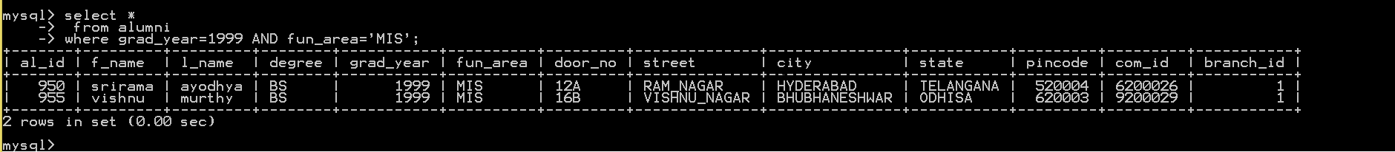

2.List all corporate names and name of the branch to which they have donated when the amount is greater than 25000 and sort the donated amount in descnding order.

Query:selectcor_name,branch_name,amount,type_of_fund,donor_id,date_of_donation from (((COR_DONATION c inner join corporate_supporters s on c.cor_id=s.cor_id)inner join FUND f on f.fund_id=c.fund_id)inner join UNIVERSITY u on u.branch_id =c.branch_id) where amount>=25000 ORDER BY amount desc;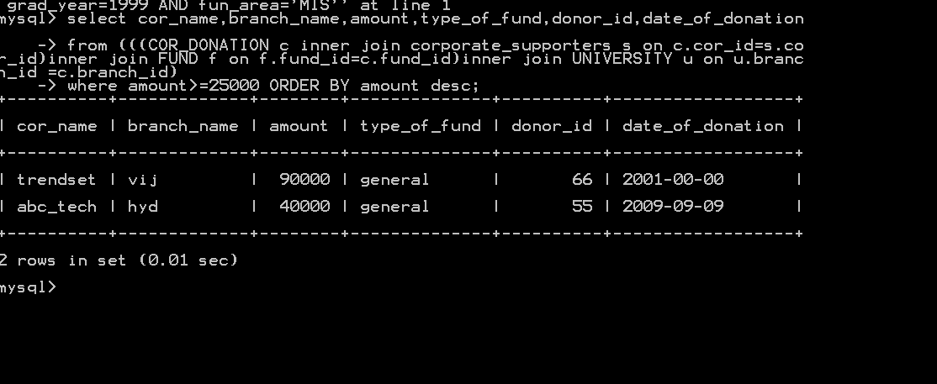

3. Display all donations made to a particular G/L(general ledger)account .The id of the donor as well as the amount of donation,date of donation,type of fund donated by corporate name abc_tech.

Query:

select donor_id,amount,date_of_donation,type_of_fund

from ((COR_DONATION c inner join corporate_supporters s on c.cor_id=s.cor_id)inner join FUND f on f.fund_id=c.fund_id)

where cor_name='abc_tech';

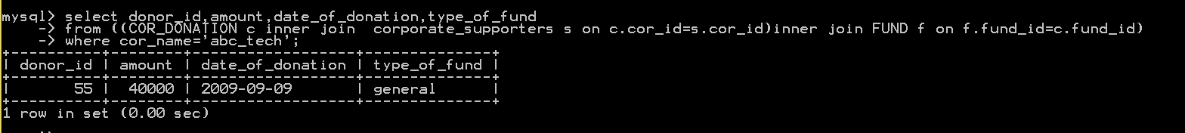

4.Display all alumni working for a particular company .display the name,join date and left date , job and salary details of individuals .

Query:

select f_name,l_name,join_date,job_title,salary,left_date

from alumni a inner join company c on a.com_id=c.com_id ;

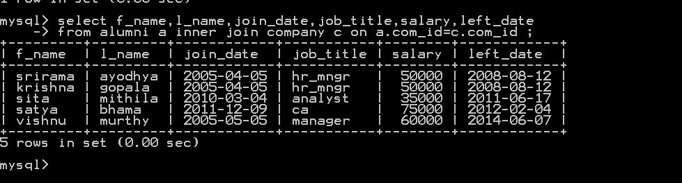

5.Display the details of alumni who has donated amount greater than 10000 to all the branches in the university.

Query:

select f_name,l_name,degree,grad_year,city,state,amount

from ((al_donation d inner join alumni a on d.al_id=a.al_id)inner join FUND f on f.fund_id=d.fund_id)

where amount>=10000 order by amount desc ;

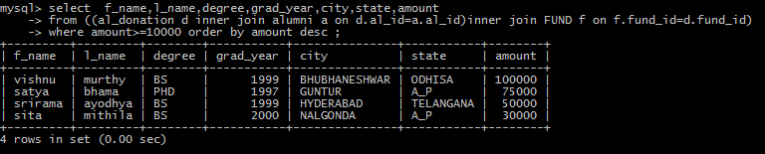

6.Display all phone numbers,phone types,of all the alumnis and count no.of phone numbers and group them according to phone_numbers of alumni.

Query:

select f_name,l_name,ph_no,ph_type,count(ph_no)

from alumni_phone p inner join alumni a on p.al_id=a.al_id;

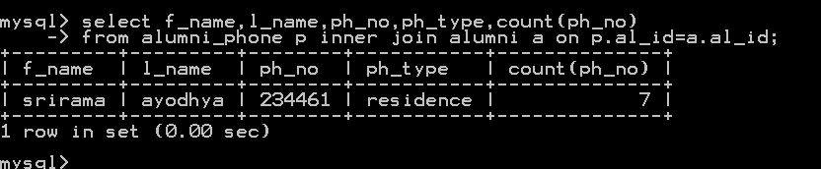

7. Display the f_name,l_name,degree,grad_year of particular alumni who had studied in university in which branch name starts with letter h.

Query:

select branch_name,f_name,l_name,degree,grad_year

from alumni a inner join university u on a.branch_id=u.branch_id

where branch_name like 'h%';

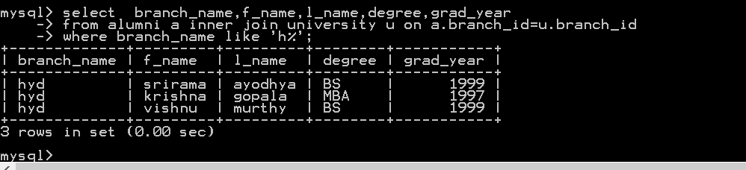

8. . Display all email_id,email types,of all the alumnis and count no.of email and group them according to email_type of alumni.

Query:

select f_name,l_name,mail_id,email_type,count(mail_id)

from alumni_email m inner join alumni a on m.al_id=a.al_id

group by email_type;

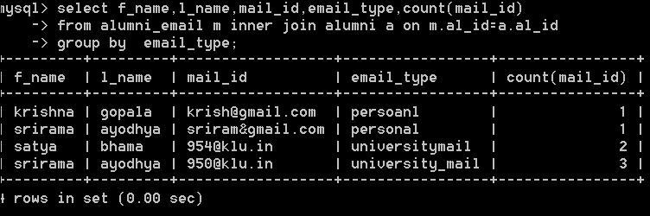

9. Display the corparate donations type_of_fund,date_of_donation and account_type to the hyderabad branch of university.

Query:

select type_of_fund,date_of_donation, account_type

from ((cor_donation d inner join fund f on f.fund_id=d.fund_id)

inner join university u on u.branch_id=d.branch_id)

where branch_name='hyd';

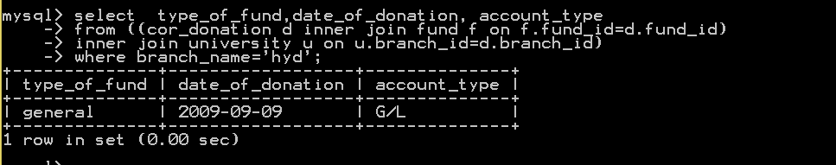

10. Display details of alumni who studied in the hyderabad branch of the university.

Query:select f_name,l_name,degree,grad_year from alumni a inner join university u on u.branch_id=a.branch_id where branch_name ='hyd';

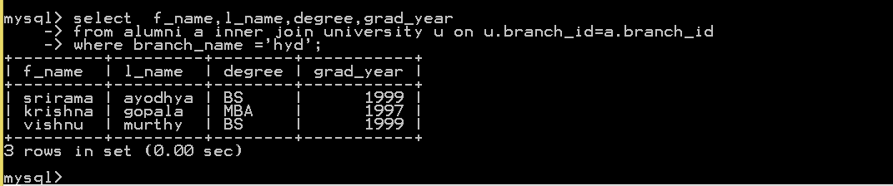

**CONCLUSION**

The alumni data base created will be very useful to store the data of the university’s alumni . Apart from the alumni data the database also stores the information of the corporate supporters that are funding the university in various aspects. A clear information can be obtained about the alumni who are donating funds to the university. The database will make it very easy to retrieve information and update the existing data.